FORM 2

THE PATENTS ACT, 1970 (39 of 1970)
&
THE PATENTS RULES, 2003

COMPLETE SPECIFICATION
(See Section 10; rule 13)

ELECTROMAGNETIC INTERFERENCE DETECTOR FOR ELECTROMAGNETIC COMPATIBILITY
APPLICANTS

S.No | Name | Address
1. | Dr.G.REVATHI | Assistant Professor, Department of ECE,  M.Kumarasamy College of Engineering,  Karur, India-639113
2. | PRAVEENA C | UG Student,  Department of ECE, M.Kumarasamy College of Engineering,  Karur, India-639113

3. | PREETHIKA P E | UG Student,  Department of ECE, M.Kumarasamy College of Engineering,  Karur, India-639113
4. | PRIYADHARSHINI SS | UG Student,  Department of ECE, M.Kumarasamy College of Engineering,  Karur, India-639113

The following specification particularly describes the invention and the manner in which it is to be performed.

SMART RIDER SAFETY SYSTEM

FIELD:

The present invention relates to the field of Intelligent Transportation Systems and vehicular safety engineering. More specifically, it refers to the design and development of a Smart Rider Safety System incorporating accident detection, fall detection, helmet-wear detection, and IoT-based emergency alert technologies. The invention aims to enhance two-wheeler rider safety by providing real-time monitoring, rapid emergency response, and continuous connectivity with emergency contacts.
The present invention pertains to the domain of Intelligent Vehicle Safety Systems and Smart Mobility Technologies. More particularly, the invention relates to a comprehensive Smart Rider Safety System for two-wheelers integrating accident detection, fall detection, helmet authentication, vehicular safety monitoring, IoT alert mechanisms, and location-tracking technologies. The invention aims to reduce accident severity by enabling autonomous emergency communication and proactive safety enforcement.
This invention relates to the domain of Intelligent Transportation Systems (ITS), Vehicular Electronics, Internet of Things (IoT), Embedded Safety Engineering, and Human–Vehicle Interaction Technologies. More specifically, it concerns a Smart Rider Safety System designed for two-wheelers that integrates helmet authentication, accident detection, vehicular status monitoring, real-time location tracking, and automated wireless communication for emergency response.The invention further relates to portable vehicular safety devices, wearable rider safety modules, and cloud-connected accident analytics systems.

BACKGROUND OF THE INVENTION

Two-wheeler accidents account for a major portion of road fatalities globally due to overspeeding, poor road visibility, and lack of safety compliance, especially helmet usage. In most accidents, the critical delay occurs between the accident and the arrival of medical assistance.
Existing systems provide either simple accident alert modules or standalone mobile applications. However, they suffer from several drawbacks:
- They do not provide real-time fall/impact detection.
- They lack automatic helmet-wear authentication.
- They do not offer instant IoT-based communication with emergency contacts.
- They rely heavily on smartphones, making the system unreliable if the phone is damaged or out of battery.
- No integrated hardware that manages speed monitoring, vibration analysis, GPS tracking, and auto-alerting in a single portable unit.
The present invention overcomes these limitations through a compact embedded system using accelerometer & gyroscope sensors, GPS & GSM communication, microcontroller-based processing, and a smart helmet-link mechanism. The system ensures rapid detection of accidents and delivers real-time alerts to designated contacts, increasing the probability of savinglives

OBJECTS OF THE INVENTION:

To provide a smart rider safety device capable of detecting accidents, falls, and high-

impact events in real time.

To implement a helmet-wear authentication module that prevents vehicle ignition until

the rider wears the helmet.

To integrate GPS and GSM technologies for transmitting emergency alerts with location

coordinates.

To provide IoT-based remote monitoring of rider safety parameters including speed, tilt

angle, and crash severity.

To create a compact, low-cost, and energy-efficient safety system suitable for any two-

wheeler.

To allow automatic SMS alerts to family members, ambulance services, or nearby

hospitals during emergencies.

To enable cloud-based storage of rider safety data for analysis, emergency response, and

predictive safety monitoring.

To reduce road fatalities by ensuring immediate emergency communication and proactive

measures.

SUMMARY OF THE INVENTION

- The Smart Rider Safety System comprises an integrated sensory and communication architecture that continuously monitors the rider’s motion, helmet status, and driving conditions. A 3-axis accelerometer and gyroscope detects impact force, angular movement, and vibration patterns. Upon detecting an abnormal spike indicating an accident, the system automatically triggers an emergency alert.

- A GPS module retrieves real-time coordinates, while a GSM module sends SMS alerts with live location to registered contacts. The system operates independently of mobile phones and uses a microcontroller for real-time processing of sensor data.

- The smart helmet includes a wear-detection sensor (IR sensor / Pressure sensor / RFID validation). The vehicle’s ignition is enabled only when the system verifies that the rider is wearing the helmet correctly.

- The entire system is powered by a rechargeable Li-ion battery with a battery management circuit for safe long-term use. The IoT connectivity uploads speed, tilt, vibration, and crash data to a cloud dashboard, enabling remote monitoring and predictive safety analysis.

- The invention serves as a life-saving device for two-wheeler riders by enabling rapid emergency response through automated alerts, thereby reducing fatality rates.
Key Summary :
- Uses sensor fusion algorithms combining accelerometer and gyroscope data.
- Helmet communicates via RF/Bluetooth/RFID for authentication.
- Accident severity is classified into levels:
  - Minor fall
  - Moderate accident
  - Severe crash
- Severe cases trigger unattended automatic emergency alerts.
- IoT platform provides crash analytics, movement pattern tracking, and safety scoring.
The system operates even when:
- mobile phone is absent
- rider is unconscious
- vehicle is off after crash

BRIEF DESCRIPTION OF THE DRAWINGS:

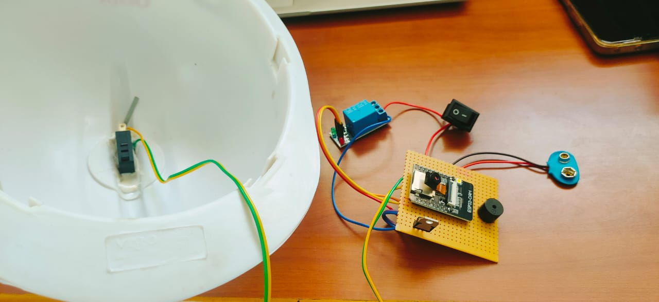

1. Safety Helmet With Tilt/Crash Sensor (Micro Switch)

- Inside the helmet, there is a micro switch fixed on the inner surface.

- This micro switch acts as the helmet detection sensor (wear detection).

- When the rider wears the helmet, the pressure flips the switch → circuit ON

- When the helmet is not worn → switch remains OFF

Wire Colors Connected to Micro Switch:

- Green, Yellow wires – these carry the signal to the control board.

2. Relay Module (Blue Component)

This is a single-channel relay module.

Function:

- Used to control the bike ignition or power circuit.

- It acts as a safety mechanism:
❌ Helmet not worn → relay OFF → vehicle will not start
✔ Helmet worn → relay ON → ignition enabled

Connections:

- Signal pin is connected to the ESP/NodeMCU

- VCC to 5V supply

- GND to common ground

3. Main Controller – NodeMCU / ESP8266

This PCB board contains the NodeMCU ESP8266, which functions as the main controller of

the system.

Functions:

- Reads micro switch (helmet worn or not)

- Activates relay

- Controls buzzer alarm

- Can also send data to mobile app (if added)

Connections:

- Input pin ← from helmet micro switch

- Output pin → relay IN
- Output pin → buzzer signal

4. Buzzer (Black Round Component)

This buzzer provides sound alerts.

Uses:

- Alerts when helmet is not worn

- Alerts on impact / crash detection

- Gives system startup beep

Connections:

- Positive terminal → ESP output pin

- Negative terminal → GND

5. Power Supply Connector (9V Battery Clip)

A 9V battery clip (blue connector) powers the system.

Connections:

- Positive → Toggle switch

- Negative → GND common

6. ON/OFF Toggle Switch (Black Square Switch)

This acts as the main power control for the system.

Working:

- When switched ON → ESP + relay get power

- When OFF → Entire safety system shuts down

BLOCK DIAGRAM:
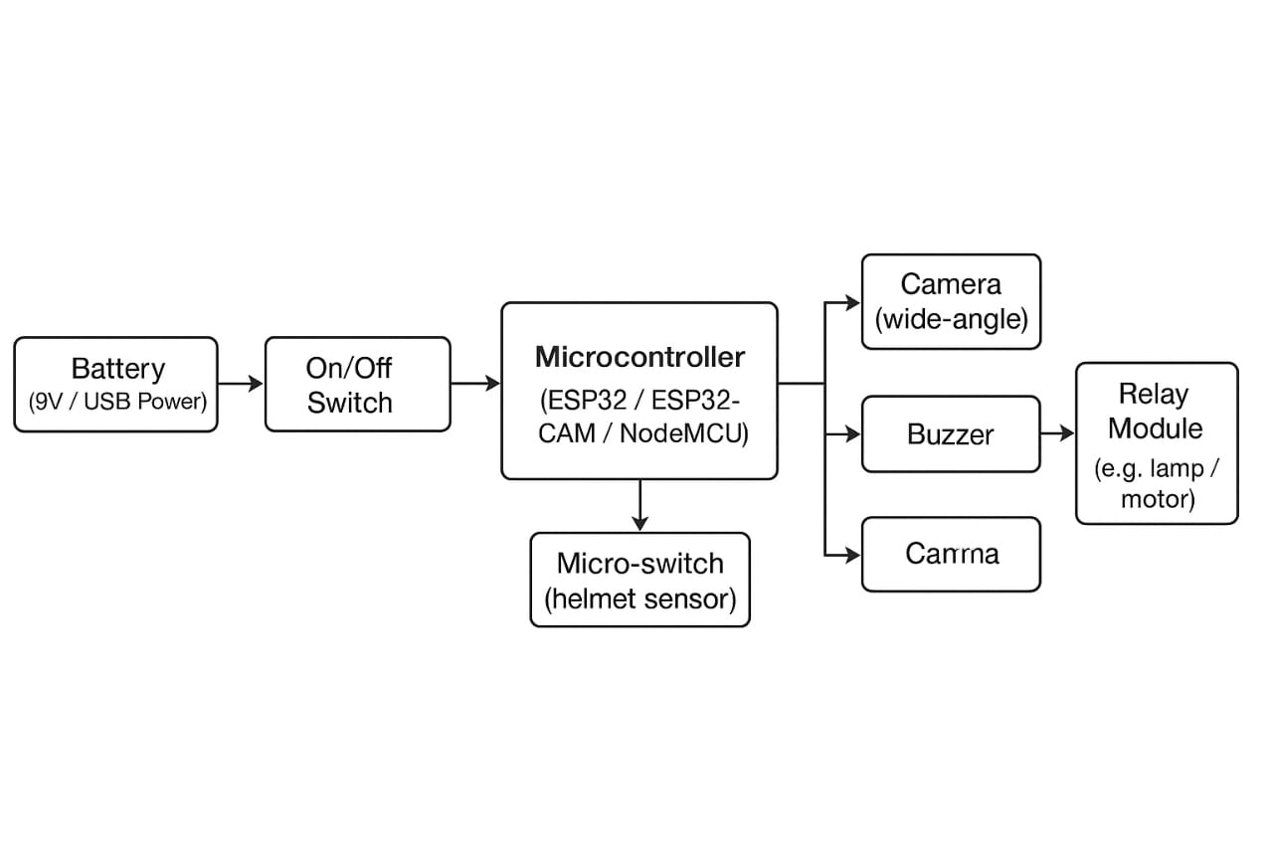
The given block diagram illustrates the working structure of a Smart Monitoring and Control System based on a microcontroller (ESP32 / ESP32-CAM / NodeMCU). This system integrates power control, sensing, alarm generation, image capturing, and external device control.

1. Power Supply Unit

Battery (9V / USB Power)
- The system is powered either through a 9V battery or a USB supply.
- Provides the necessary voltage required to operate the microcontroller and peripherals.
- Ensures portability and independent operation without dependency on mains power.

On/Off Switch
- The switch is placed between the battery and microcontroller.
- It helps to manually start or stop the entire system.
- Prevents unnecessary power consumption when the system is not in use.

2. Microcontroller

ESP32 / ESP32-CAM / NodeMCU
- This is the central processing unit of the system.
- It receives inputs from sensors, processes signals, and controls output devices.
- Includes:
  - Built-in Wi-Fi & Bluetooth for wireless communication
  - GPIO pins for sensor and actuator interfacing
  - Camera interface (in ESP32-CAM)
- Executes code written in Arduino IDE / MicroPython / C++.
The microcontroller acts as the brain of the project, coordinating all actions based on programmed logic.

3. Input Section

Micro-switch (Helmet Sensor / Trigger Switch)
- This micro-switch acts as an input trigger.
- It detects a physical event such as:
  - Helmet worn (pressure applied)
  - Safety door closed
  - Button pressed
- When the switch is activated, it sends a digital signal (HIGH/LOW) to the microcontroller.
- The microcontroller uses this signal to decide whether to activate output components.

4. Output Section
After receiving the input signal, the microcontroller controls the following output modules.

A. Camera (Wide-Angle Lens)
- Captures video or images depending on the project requirement.
- Can monitor surroundings or record activity.
- Wide-angle lens allows a larger field of view.
- If connected to Wi-Fi, the captured data can be:
  - Live-streamed to a smartphone
  - Stored in cloud or SD card
Example use:
If helmet is worn → camera activates → photo / video captured for identity or safety monitoring.

B. Buzzer (Alarm / Notification)
- Generates sound alerts to notify the user.
- Can indicate:
  - System activation
  - Safety breach
  - Warning or alert message
- Controlled directly from digital GPIO pins.
Example use:
If trigger is activated → buzzer beeps to indicate system ON or danger detected.

C. Relay Module (High Power Switching)
- A relay is an electrically operated switch used to control high-power devices.
- The microcontroller sends a low-power signal to the relay.
- Relay switches ON/OFF high-voltage loads .
Example use:
Helmet detection → Relay enables ignition ON / or turns on safety lamp.

CLAIMS

I / We claim,
- A Smart Rider Safety System comprising:

  - a microcontroller for processing rider safety data.

  - a helmet authentication module

  - a GPS module for real-time positioning

- The system of claim 1, wherein the helmet authentication prevents vehicle ignition until

proper helmet wear is detected.

- The system of claim 1, wherein GPS provides real-time coordinates for emergency

mapping.

- The system of claim 1, wherein GSM sends automated SMS alerts with live location to

emergency contacts.

- The system of claim 1, wherein the device is portable, low-power, and suitable for all

two-wheelers.

Signature of Applicants:

G.REVATHI | C.PRAVEENA | P.E. PREETHIKA | S.S. PRIYA DARSHINI

ABSTRACT

This invention relates to a Smart Rider Safety System designed to enhance two-wheeler rider safety using embedded sensors, GPS, GSM, and IoT technologies. The system detects accidents and falls using an accelerometer and gyroscope, verifies helmet usage through a helmet authentication module, and provides real-time emergency alerts through GSM communication. GPS retrieves accurate location coordinates, while IoT connectivity enables cloud storage and remote monitoring of rider data. The invention provides a low-cost, portable, and reliable solution to reduce two-wheeler fatalities by offering immediate emergency communication and continuous-rider-safety-supervision.
The Smart Rider Safety System integrates helmet verification, crash detection, real-time GPS location tracking, and GSM-based emergency alerts into a single embedded unit. Sensor fusion technology enables accurate detection of falls, impacts, skids, and severe crashes. Helmet authentication ensures safety compliance while ignition locking prevents unauthorized or unsafe riding. The system autonomously sends SMS alerts with location coordinates during emergencies and uploads safety logs to a cloud dashboard for continuous monitoring. Designed for universal compatibility, the invention enhances rider safety, reduces emergency response time, and provides an intelligent, IoT-enabled safety ecosystem for two-wheeler.

